1. **Write a C program to search a number using Binary Search method.**

**PROGRAM:**

#include <stdio.h>

int binarySearch(int arr[], int left, int right, int target) {

while (left <= right) {

int mid = left + (right - left) / 2;

if (arr[mid] == target)

return mid;

if (arr[mid] < target)

left = mid + 1;

else

right = mid - 1;

}

return -1;

}

int main() {

int arr[] = {2, 4, 6, 8, 10, 12, 14, 16, 18, 20};

int n = sizeof(arr) / sizeof(arr[0]);

int target = 12;

int result = binarySearch(arr, 0, n - 1, target);

if (result == -1)

printf("Element not found\n");

else

printf("Element found at index %d\n", result);

return 0;

}

**INPUT:**

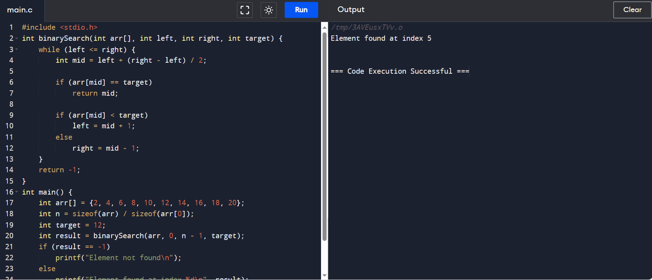

**OUTPUT:**

